Materials Policy Template

The purpose of this document | To provide a foundation for you to create your own Materials Policy by outlining key areas to include.
Who it is for | The Waste Lead should fill out this template. Once written, it should be shared with teams and companies that are likely to create waste at your event.
How to use it | Adapt the template to create a specific version for your own event. Share it with all teams and companies likely to create waste so they know in advance what materials they should not bring onsite.

See the page below for the policy template.

<Event Logo>

<Event Name> Materials Policy

<Event name> is committed to adopting the principles of the Waste Hierarchy (see below). This means our first preference is to use materials that avoid waste or that can be reused multiple times. If this is not possible, recyclable materials are the next best option. Please help us to achieve these principles.

We will work with our event teams, contractors and audiences to:
- Avoid and minimise materials that become waste.
- Separate waste streams to achieve higher rates of recycling.
- Work with waste contractors to deliver successful waste management onsite.

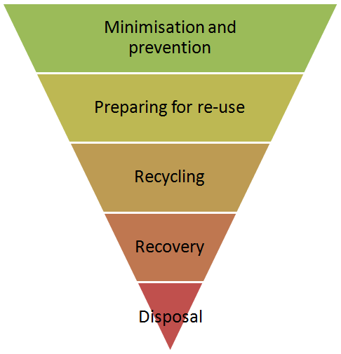
The Waste Hierarchy
  - Minimisation and prevention: Can the item be borrowed or hired to avoid waste?
  - Re-use: Is it built to last or repurposed so the item can be used again?
  - Recycle: Is the item made from a material that is recyclable?
  - Recovery: Can any energy or resources be recovered?
  - Disposal: Can this be avoided?

Key policies/campaigns/waste measures: <add or delete as appropriate> :
- e.g. Reusable bar cups
- Types of hot cups
- <Add any further materials policies you have>.

Prohibited materials <delete or add as required>

[Examples provided below of typical materials an event may avoid]

The following materials / products are not permitted onsite at this event:
- Single-use cups
- Plasterboard
- Paint tins with paint (please take home with you if you need them)
- Polystyrene (any type for any use)
- Old sofas / furniture
- Nitrous Oxide canisters - ‘NOS’ (used or not)
- Plastic glitter
- <Add any further materials you wish to ban>.

See the Industry Waste Briefing for useful information on legal requirements around certain material types here.

Please avoid or reduce:
[Examples provided below of typical materials an event may reduce or avoid]
We aim to reduce / minimise these materials onsite:
<delete/add as appropriate>
- Single-use materials
- Packaging
- Plastics
- MDF
- Single-use cable ties
- <Add any further materials you wish to reduce>.

Managing waste materials onsite
The table below shows how we aim to minimise and manage materials onsite. Please plan your work/projects with this in mind from the outset. Information will be provided about the waste management and recycling systems onsite before and at the event.

<delete as appropriate>

Material category | Types to avoid | Types to choose -  or actions to take - if possible
Wood | - MDF as this can’t be recycled and is full of toxic glue. | - Hired in materials  - Reused wood  - FSC certified products.
Cable ties | - Single-use. | - Reusable
Paper | - Paper with no sustainable certifications (e.g. FSC, PEFC, certified recycled) | - Minimise printing  - Provide staff with tablets  - Choose recycled paper.
Single-use plastics | - Bottled water  - Bottled soft drinks  - Single-use cups. | - Reusable bottles & access to tap water  - Canned soft drinks  - Reusable cup scheme.
Compostable plastics | - Avoid if you don't have a separate waste collection for these. | - Reusable materials  - Materials that can be recycled.
Single-use packaging | - Minimise where possible. | - Reusable options  - Request suppliers send items in reusable packaging e.g. blankets and ratchets.
Food |  | - Provide accurate audience/crew figures so caterers can plan accordingly.  - Find a local surplus food charity to collect quality in-date food.
Serveware | - Single-use plastic, polystyrene or PLA | - Bagasse - i.e. with no plastic or compostable lining  - Talk to waste contractors about what can be accepted and the waste stream.
Furniture | - Avoid bringing old second-hand furniture onsite - if it breaks it is hard to dispose of due to POP regulations. | - Hire in furniture.
Tents |  | - Run a comms campaign with audiences to take tents home  - Book a tent hire company for the event.
Electronic items |  | - Hire in  - Buy second-hand.
Fencing | - Single-use or scrim products. | - Reuse scrim (where possible).

<Add any further materials you wish to list>

