Food Trader Waste Guidelines Template

Purpose of this document | To provide a foundation for you to create your own guidelines for food traders.
Who it is for | Waste Lead and/or Trader/Concessions Manager to complete and share with food traders.
How to use it | Fill in this template to create guidelines for food traders. Delete or add information as required and highlighted in the text.

See below for the Food Trader Waste Guidelines Template.

<Event Logo>

<Event Name> Guidelines for Food Traders
Overall aim
<explain key aims e.g. We aim to recover and recycle 100% of recyclable materials onsite, and separate food waste for composting.>
<briefly outline success so far to demonstrate e.g. percentages>
How we will support you:
- We will provide an A4 laminate of the recycling instructions for you and your staff to follow.
- We will collect appropriately sorted waste from your Back-of-House area <every day (or when you plan to do this)>
- We will provide <outline bins provided if any e.g.> food bins for cooked and uncooked food and sacks for cardboard in close proximity to your stall. (Please ensure the cardboard is clean, flattened and with any plastic wrap removed!)
- We will provide <bins / green sacks or similar – insert> for dry mixed recycling (NO FOOD WASTE other than residues on empty cans and jars).
- WE will provide <bins or state receptacle type> for waste that is not recyclable e.g. crisp packets, dirty baking foil and soiled card e.g contaminated with mut or food fat (classic being pizza boxes).
<if using bin toppers or signage for back of house waste, insert images>
What we expect from you:
- <if not provided by the festival> To have three adequate bins in your Back-of-House area to sort waste.
- To place food waste in the Back-of-House compost bins <if provided or state otherwise>.
- To flatten cardboard and put in the relevant <sacks/bin>.
- To work with the <Recycling Team/Site Manager> to sort and segregate your waste as requested.
- To NOT put any recyclables or food waste in the landfill <bin>.
- To NOT contaminate clean dry recyclables with food waste.
- To brief and monitor your staff on these procedures.

FOOD TRADER ONSITE WASTE DISPOSAL GUIDE

WASTE STREAM | SEGREGATION REQUIRED | TRADER BINS PROVIDED | ONSITE SYSTEM OF REMOVAL
Mixed dry recycling | Plastic (including clean plastic film), cans, tins, tetra pak and glass.
Compost | Food waste.
Cardboard/paper | All CLEAN, DRY cardboard & paper (no card contaminated with; food, meat juices or grease e.g. pizza box).
Cooking oil/fats

Other waste | Non recyclables, e.g.  materials contaminated (with food, grease or mud), wrappers, packaging, foil or card, crisp packets, broken china, nappies, cleaning cloths (including blue paper), sponges and textiles. |  | e.g. The recycling team will collect from behind your stall.
Good/edible food | Day old bread/pastries. Pies / fruit & veg.

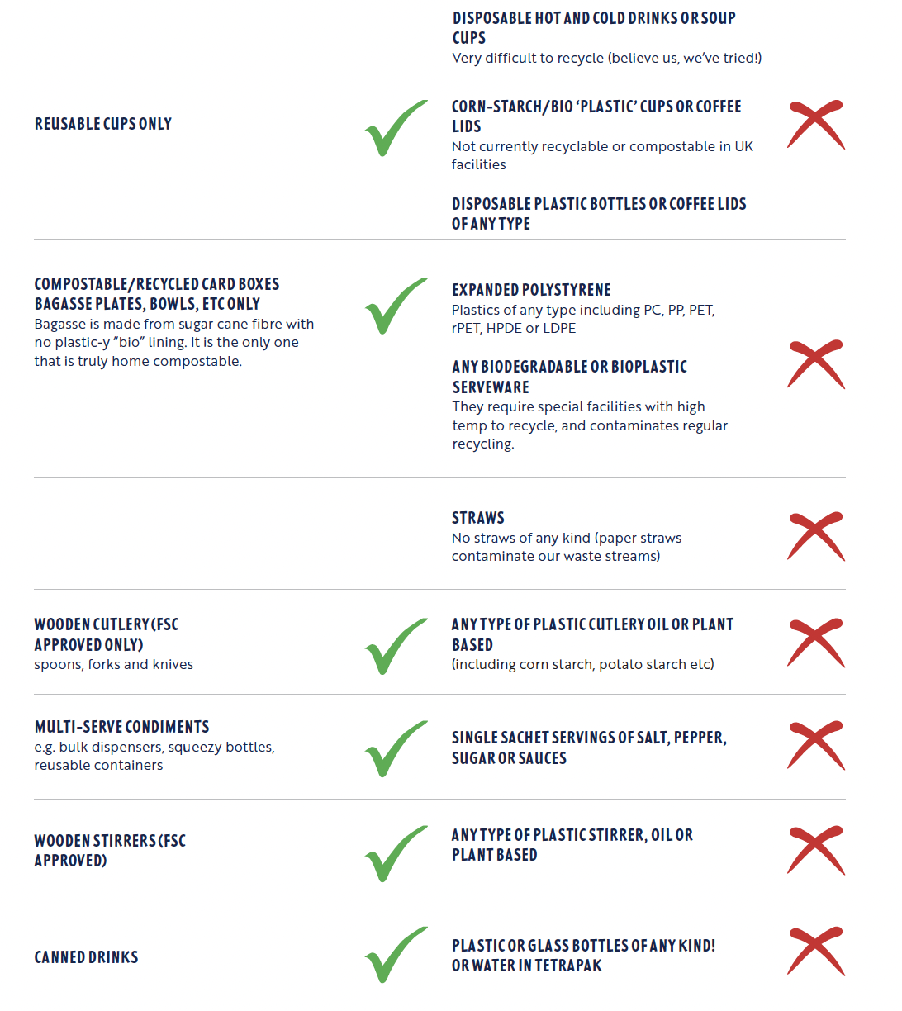

Before you leave…
Please ensure you have requested the <insert role e.g. Trader Manager> to attend your pitch and sign it off as clear before departure.

